**Drone & Tools List**

|  |  |  |  |
| --- | --- | --- | --- |
| Component List | | | |
| Item | Part | Quantity | Cost |
| 1 | Frame | 1 | £17.30 |
| 2 | Motors | 4 | £20.80 |
| 3 | Electronic speed controllers | 6 | £19.39 |
| 4 | Battery | 1 | £18.05 |
| 5 | Battery Charger | 1 | £15.99 |
| 6 | Propeller | 10 | £2.06 |
| 7 | Inertial measurement unit | 1 | £3.39 |
| 8 | Male to Female jumper wires | 1 | £3.99 |
| 9 | Cable Ties Pack | 1 | £3.99 |
| 10 | Arduino Uno WIFI Rev 2 | 1 | £9.99 |
| 11 | Silicone Cable | 2 | £7.59 |
| 12 | Heat Shrink Tubing Pack | 1 | £5.99 |
| 13 | Prototype Printed Circuit Board | 1 | £9.99 |
| 14 | Velcro Cable Tie Black | 1 | £8.99 |
| 15 | Double sided sticky pads | 5 | £5.99 |
| Total | | | £153.32 |

|  |  |  |
| --- | --- | --- |
| Item | Tools | Quantity |
| 1 | Soldering Iron | 1 |
| 2 | Solder Wire | 1 |
| 3 | Wire strippers | 1 |
| 4 | Alen Key | 5 |
| 5 | Pliers | 1 |
| 6 | Scissors | 1 |
| 7 | Calliper | 1 |
| 8 | Mask 4251 | 1 |

**1.Frame**

Quadcopter F330 33cm Frame

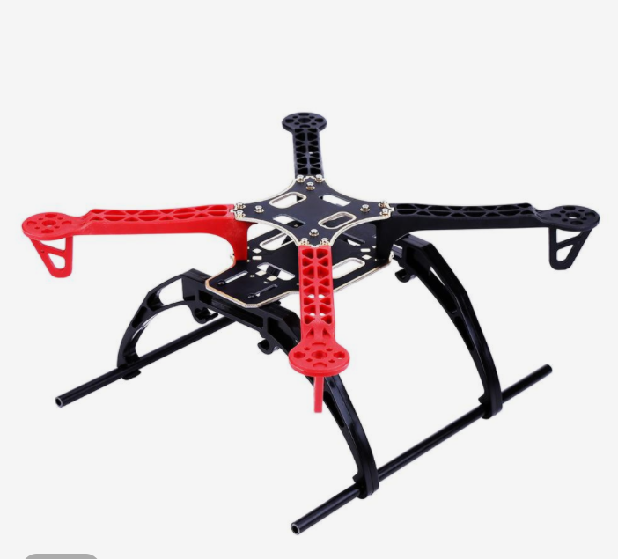

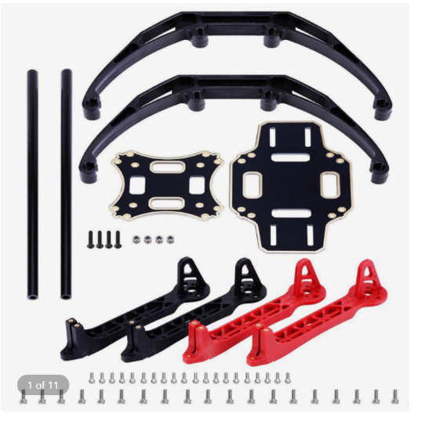

**2.Motors**

Racerstar BR2212 2200KV 2-3S Brushless Motor for Quadcopter

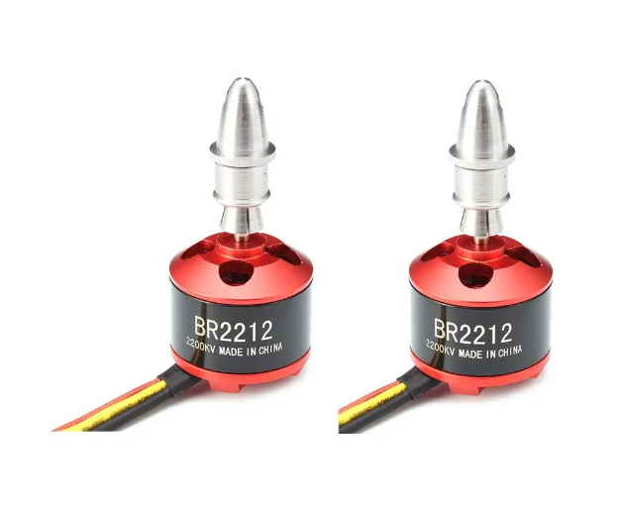

**3.Electronic speed controllers [ESC]**

6PCS XXD HW30A 30A Brushless ESC for Quadcopter

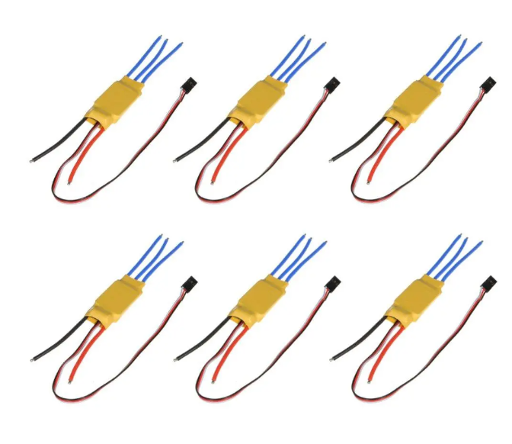

**4.Battery**

Makerfire 1500mAh 11.1V 3S Lipo Battery 45C

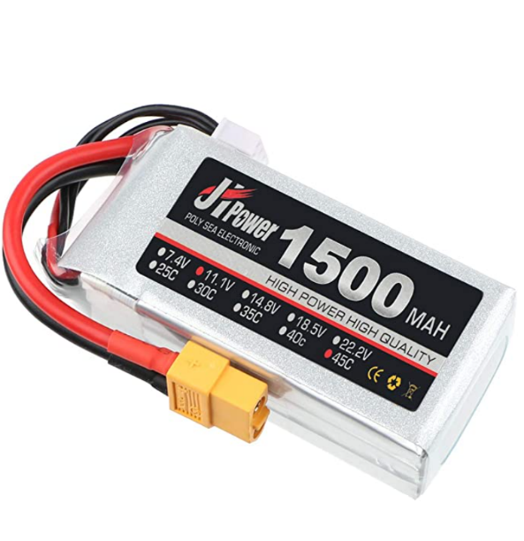

**5.Battery Charger**

SKYRC e3 Lipo Balance Charger 15W 100-240V for 2-3s LiPo Battery

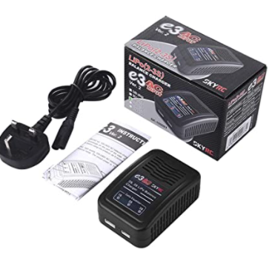

**6.Propellers**

10pcs 6030 ABS Direct Drive Orange Propeller Blade

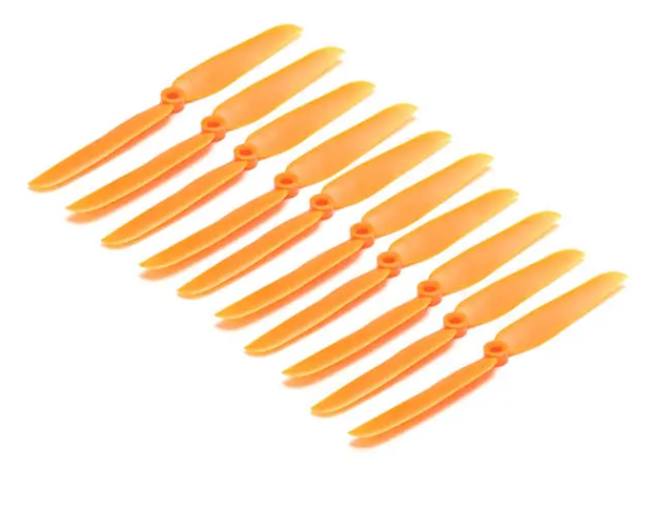

**7. Inertial measurement unit [IMU]**

MPU-6050 Module: 3-axis Gyroscope and 3-axis Accelerometer

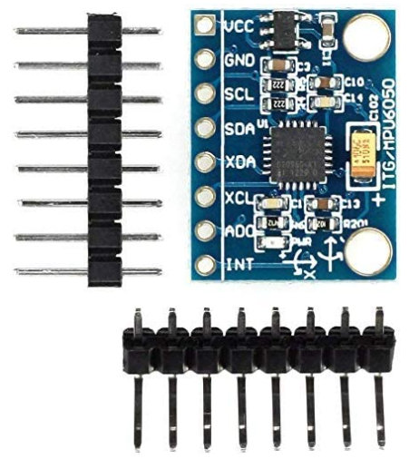

**8.** **Male to female jumper wires**

1480 Pieces Resistor Kit 0 Ohm-1M Ohm

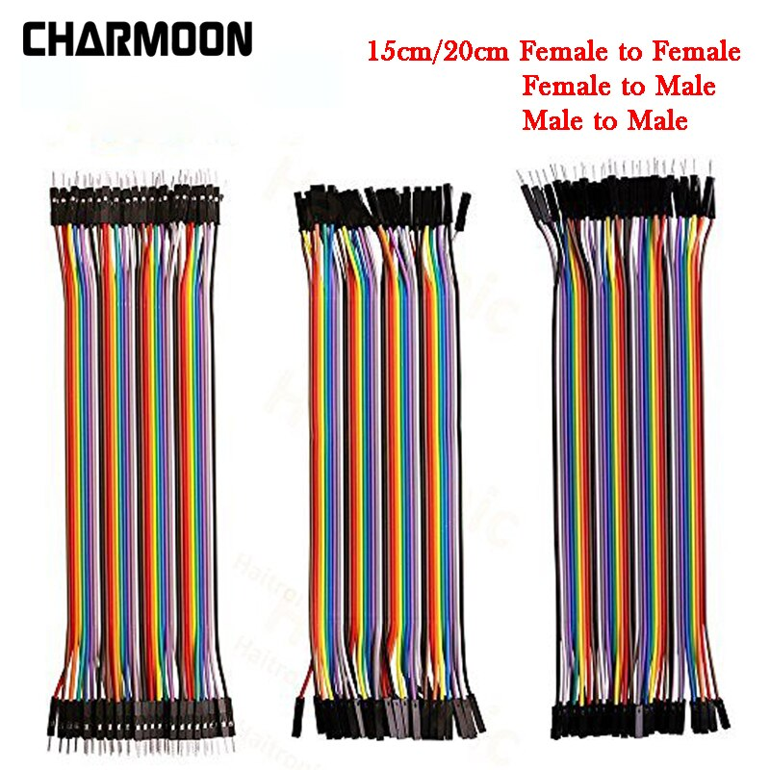

**9.** **Cable Ties**

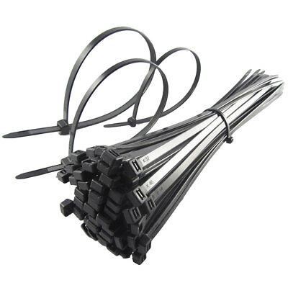

**10.Arduino Uno WIFI Rev2**

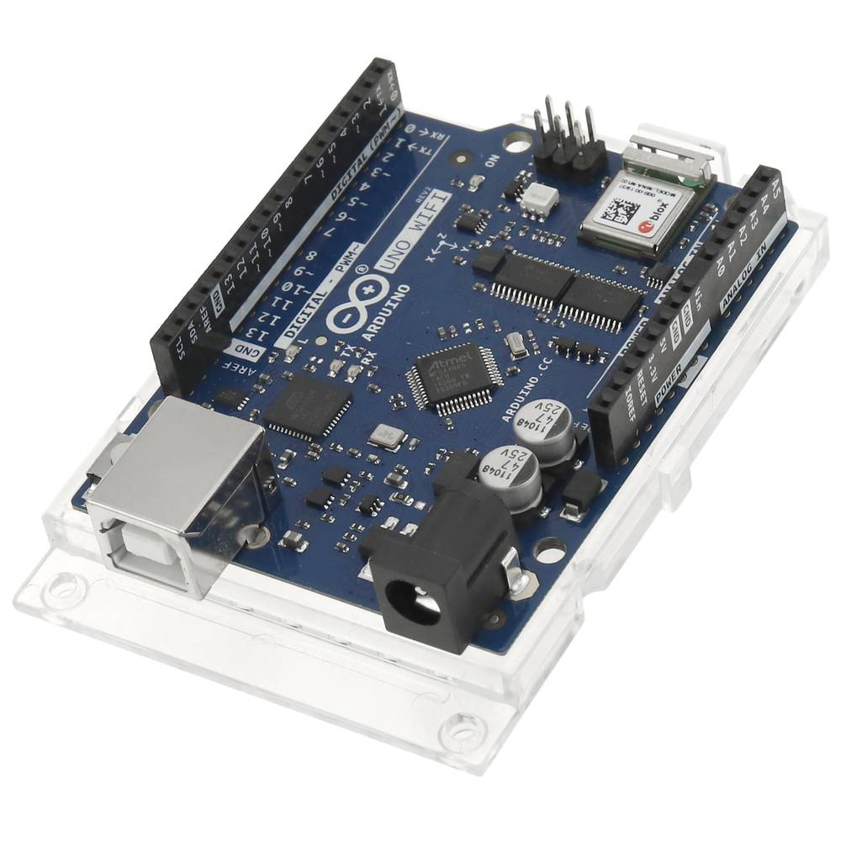

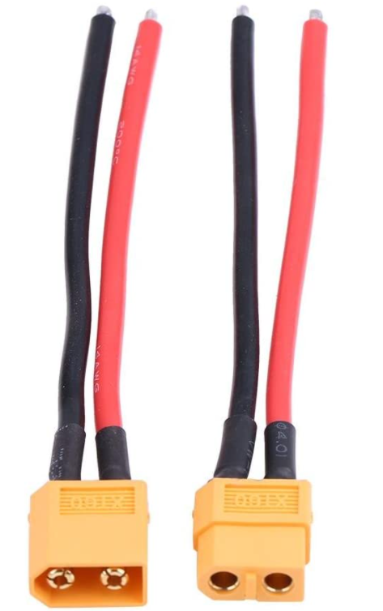

**11.Silicone Cable**

Dilwe 2 Set XT60 Female Male Cable, Connector Adapter 14AWG Silicone Cable

**12.Heat Shrink Tubing Pack**

164 Pcs Heat Shrink Tubing

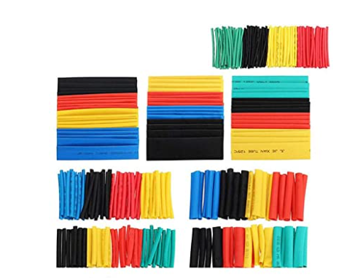

**13. Prototype Board**

**14. Velcro Cable Tie Black**

**15. Double sided sticky pads**

